**Excel Import**

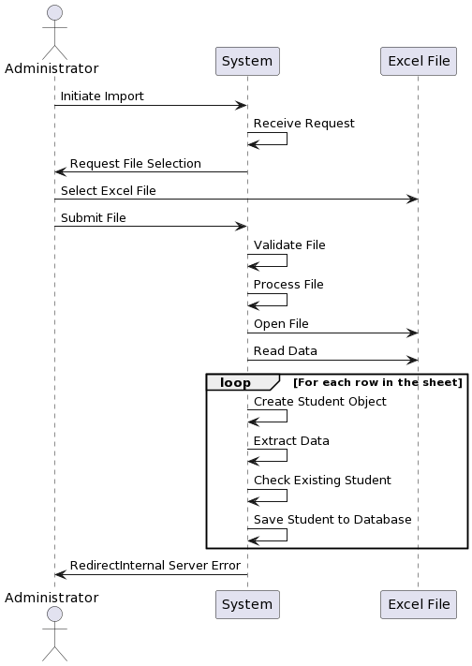

actor Administrator as Admin

participant System

participant "Excel File" as ExcelFile

Admin -> System: Initiate Import

System -> System: Receive Request

System -> Admin: Request File Selection

Admin -> ExcelFile: Select Excel File

Admin -> System: Submit File

System -> System: Validate File

System -> System: Process File

System -> ExcelFile: Open File

System -> ExcelFile: Read Data

loop For each row in the sheet

System -> System: Create Student Object

System -> System: Extract Data

System -> System: Check Existing Student

System -> System: Save Student to Database

end

System -> Admin: RedirectInternal Server Error